1)Open Windows Firewall Settings

Go to: Control Panel → System and Security → Windows Defender Firewall.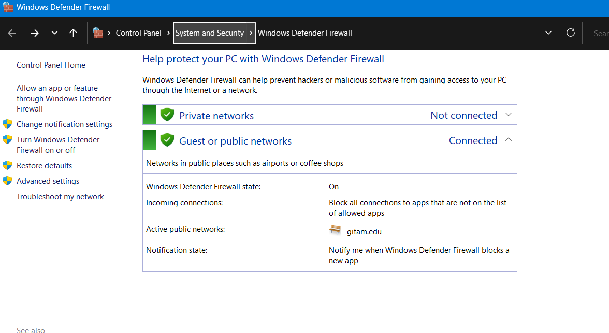

2) **View current rules**

* Click on “Advanced settings”.

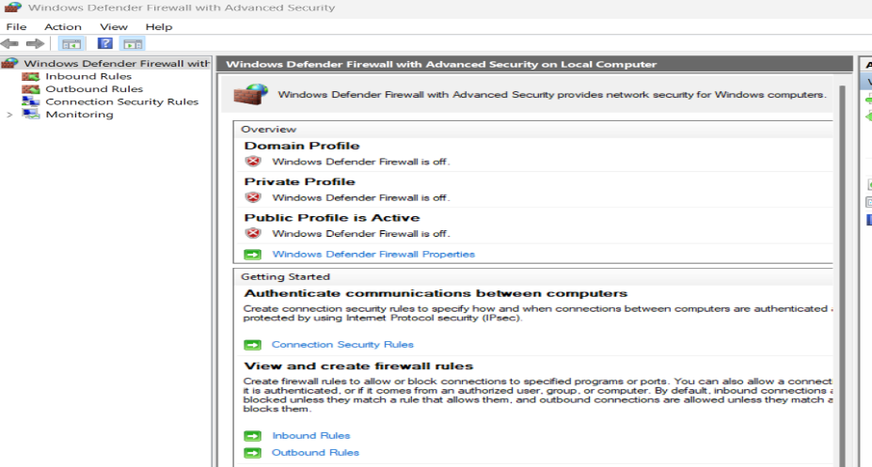

**3)Create a new inbound rule to block port 23**

* Inbound Rules → New Rule → Port → TCP → Port 23 → Block the connection.

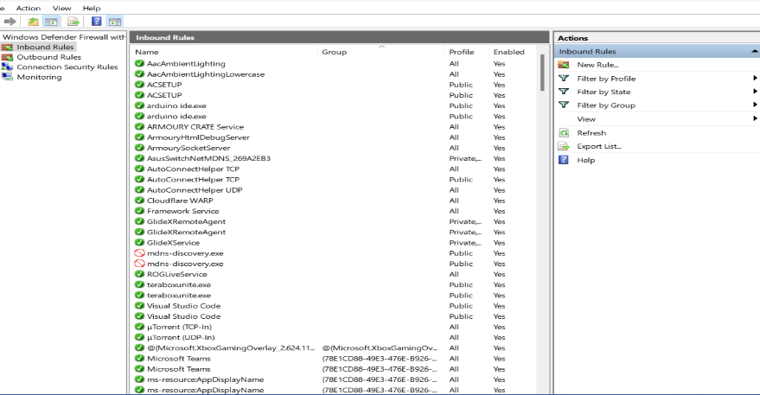

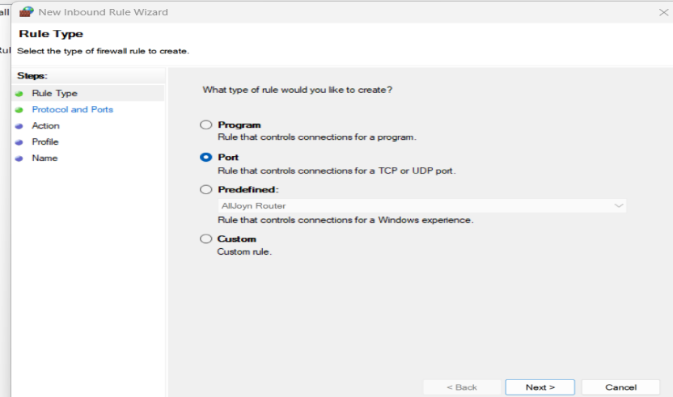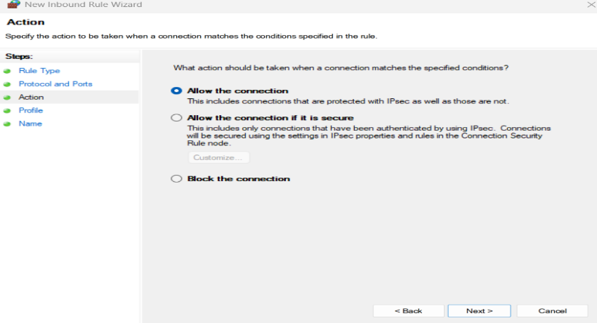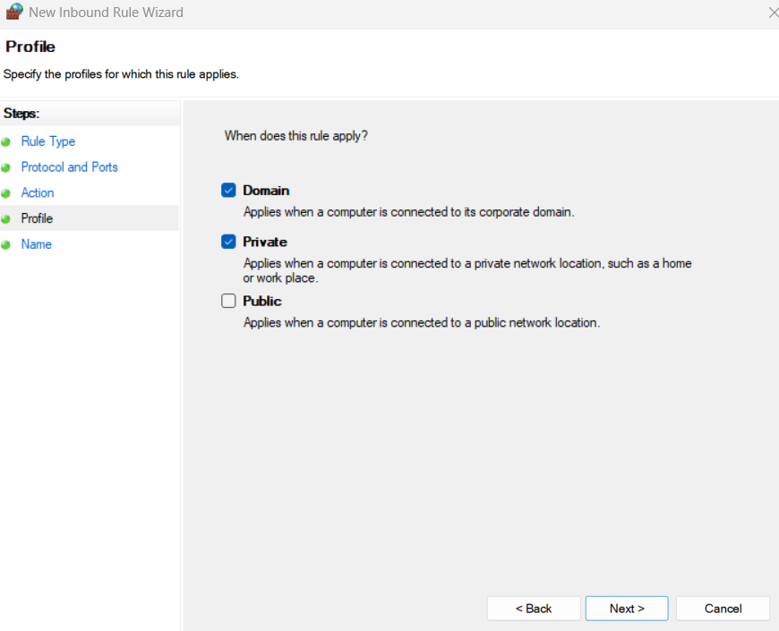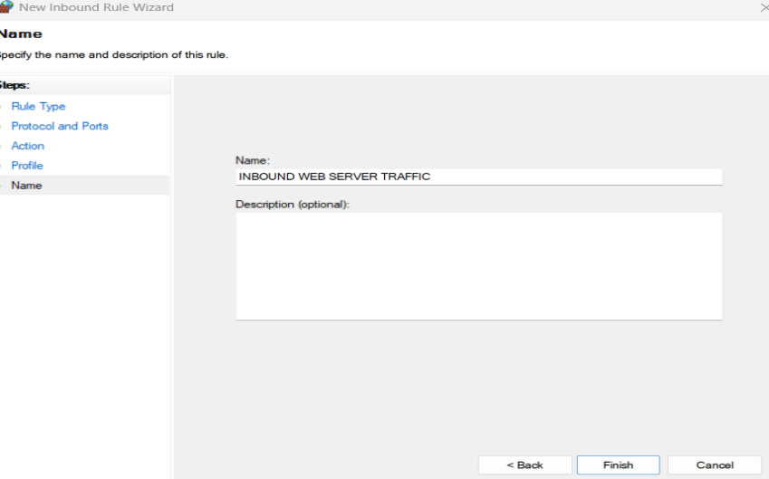

4) **Remove the test block rule**

* Find the rule in “Inbound Rules” → Right-click → Delete.

